# SUBMITTED TO: Mr. DEEPAK SHARMA

# NAME: SANJHI JAIN

**Course: B. Sc. (H) Computer Science, III Year, VI Semester**

**COLLEGE ROLL NO: CSC/21/19**

**UNIV ROLL NO: 21059570046**

**PRACTICAL FILE FOR COMPUTER GRAPHICS**

**PRACTICAL 01**

**1. Write a program to implement DDA and Bresenham’s line drawing algorithm.**

**CODE**

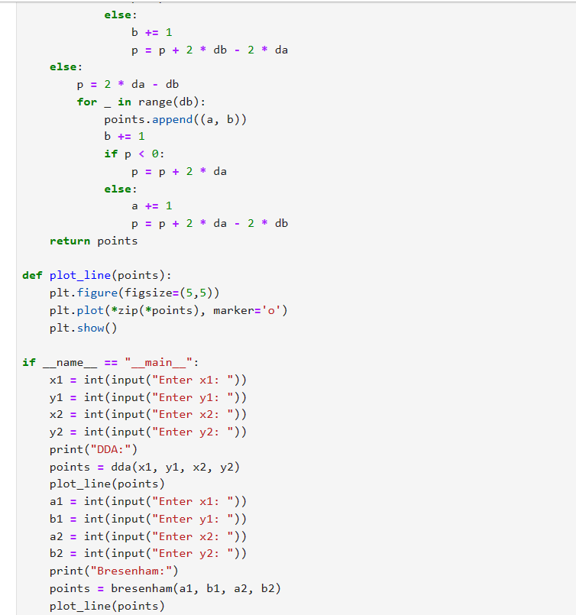

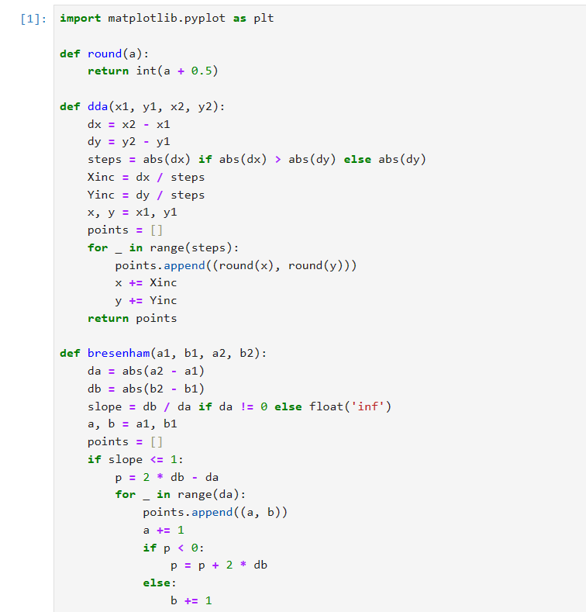

**OUTPUT**

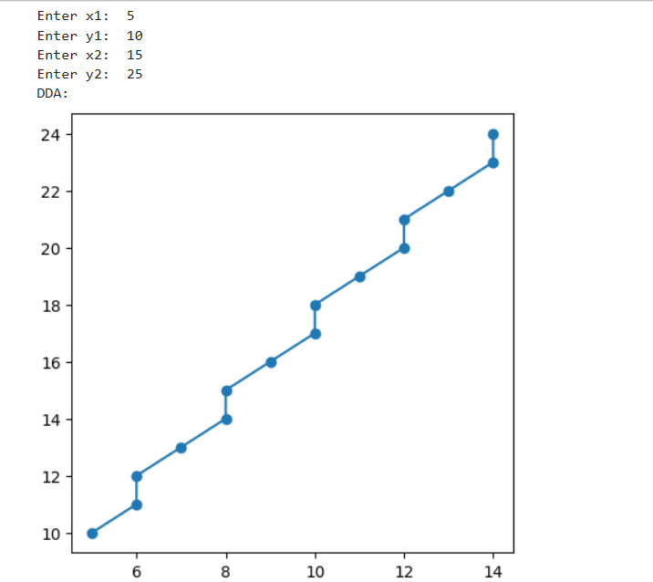

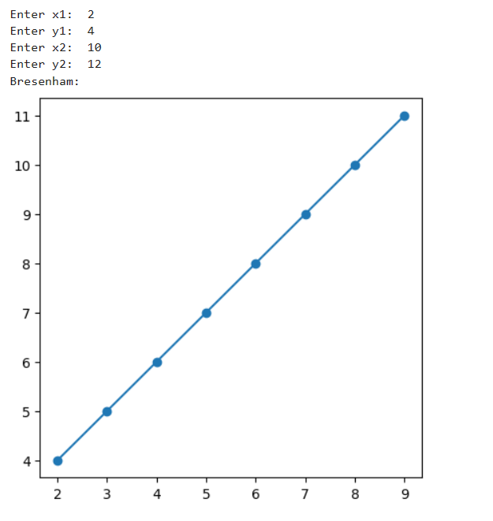

**PRACTICAL 02**

**2. Write a program to implement mid-point circle drawing algorithm.**

**CODE**

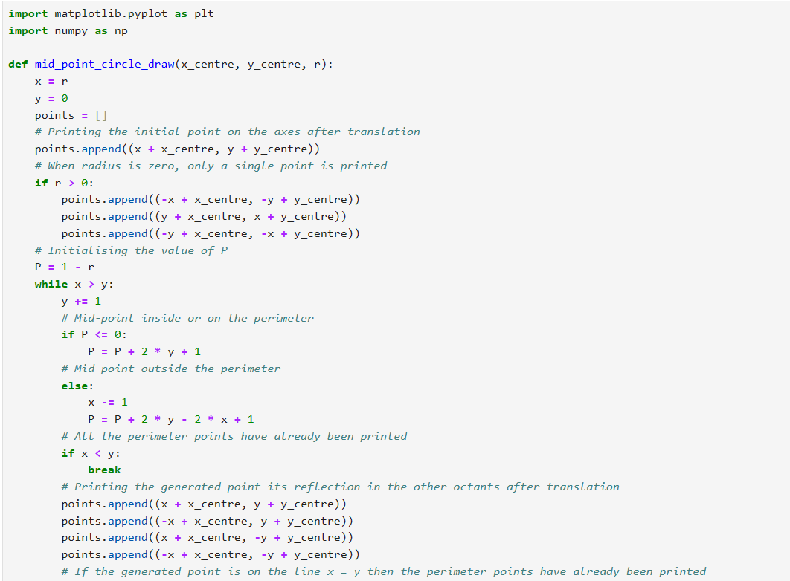

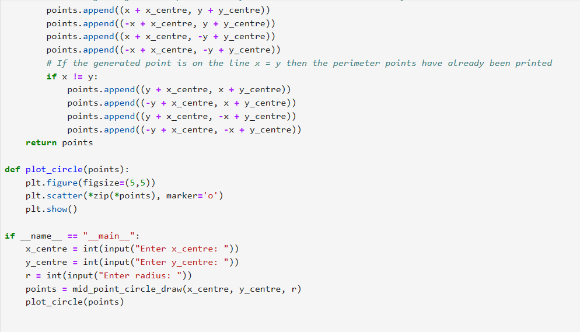

**OUTPUT**

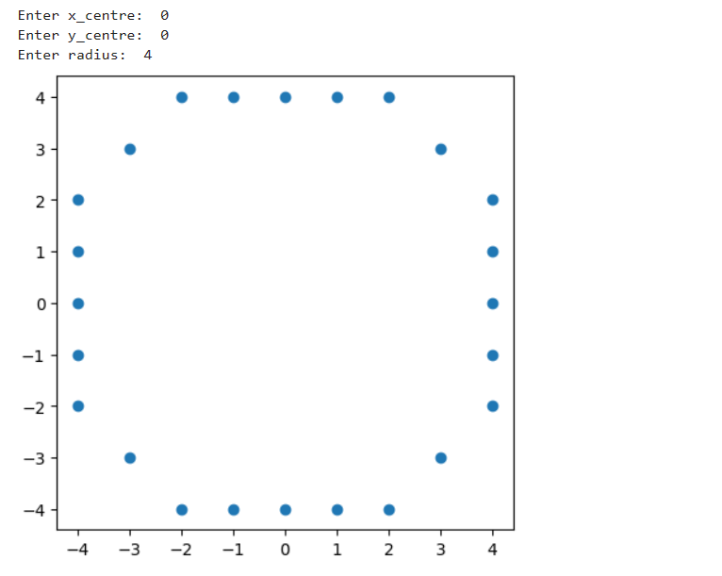

**PRACTICAL 03**

**3. Write a program to clip a line using Cohen and Sutherland line clipping algorithm.**

**CODE**

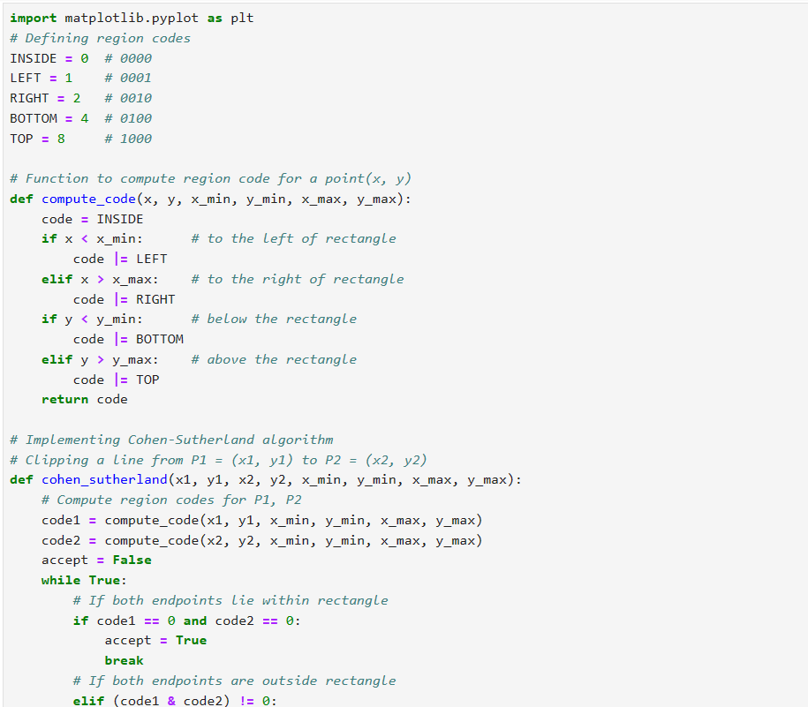

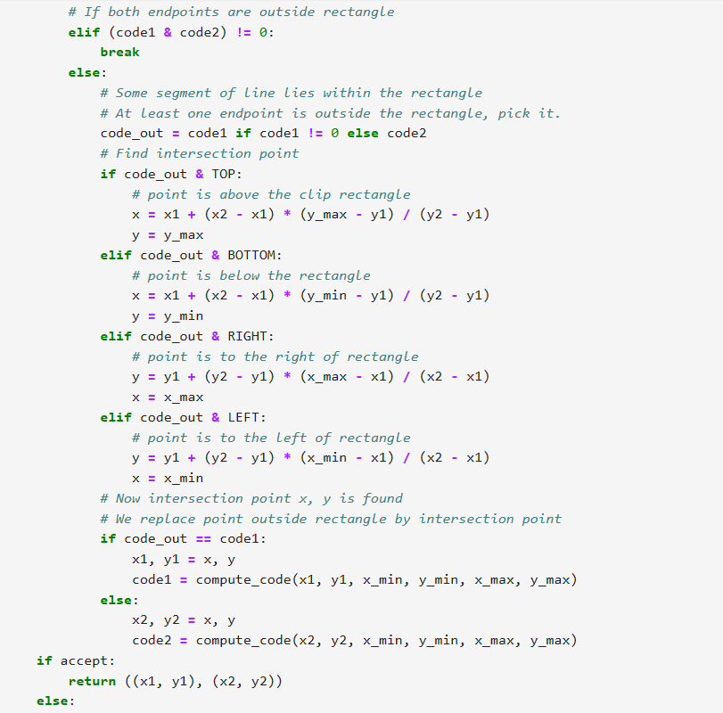

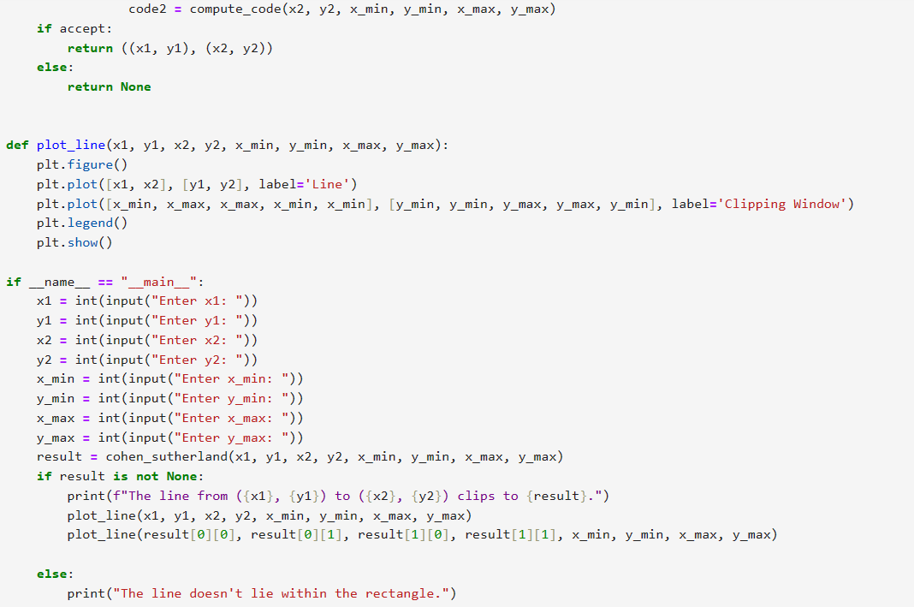

**OUTPUT**

**FOR PARTIALLY INSIDE**

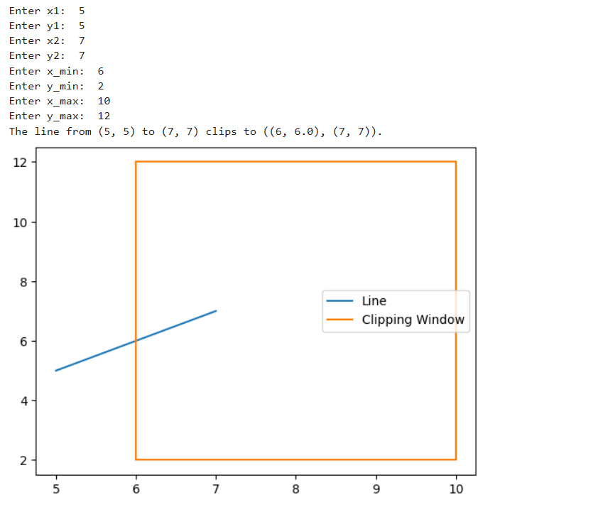

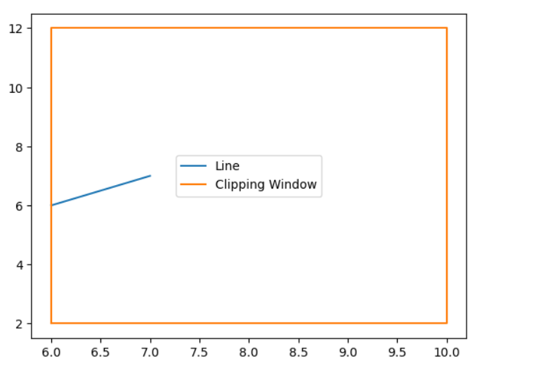

**COMPLETELY INSIDE :**

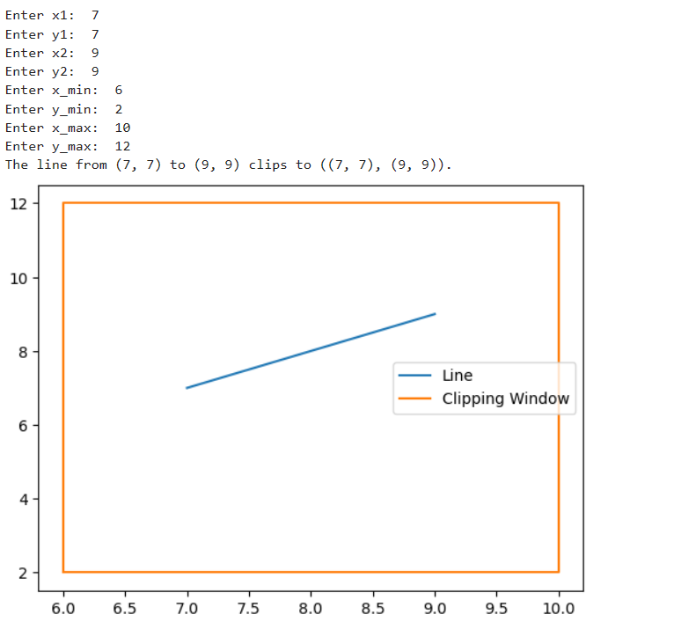

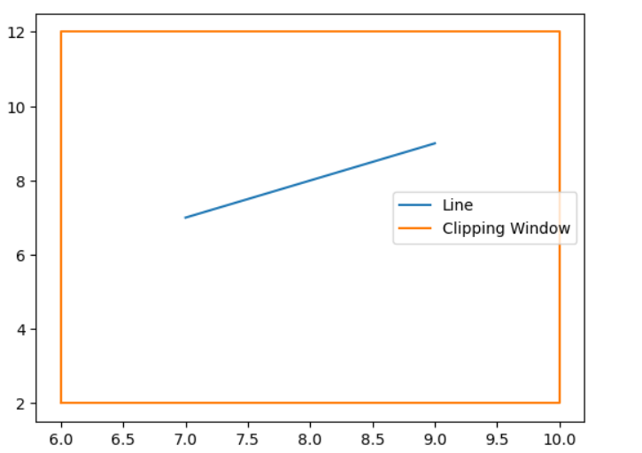

**COMPLETELY OUTSIDE:**

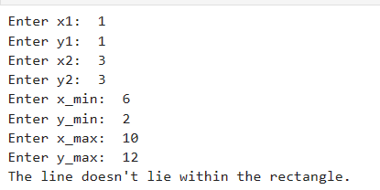

**PRACTICAL 04**

**4. Write a program to clip a polygon using Sutherland Hodgeman algorithm.**

**CODE**

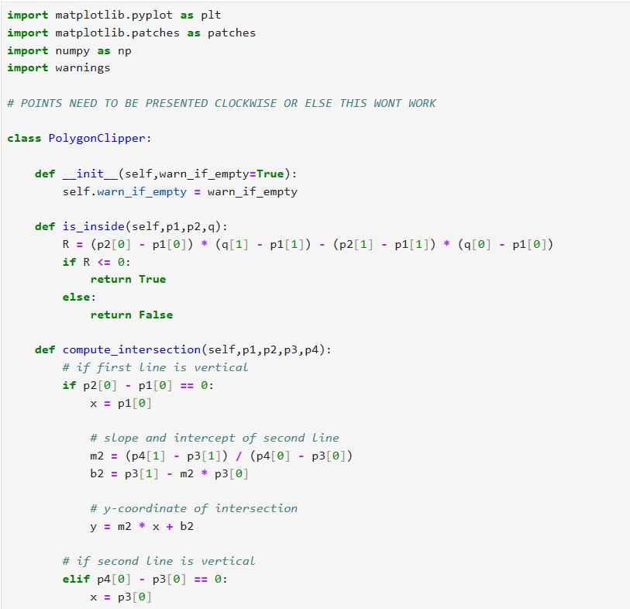

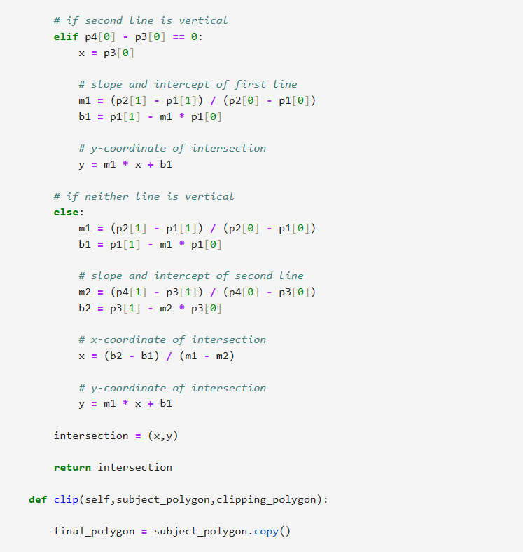

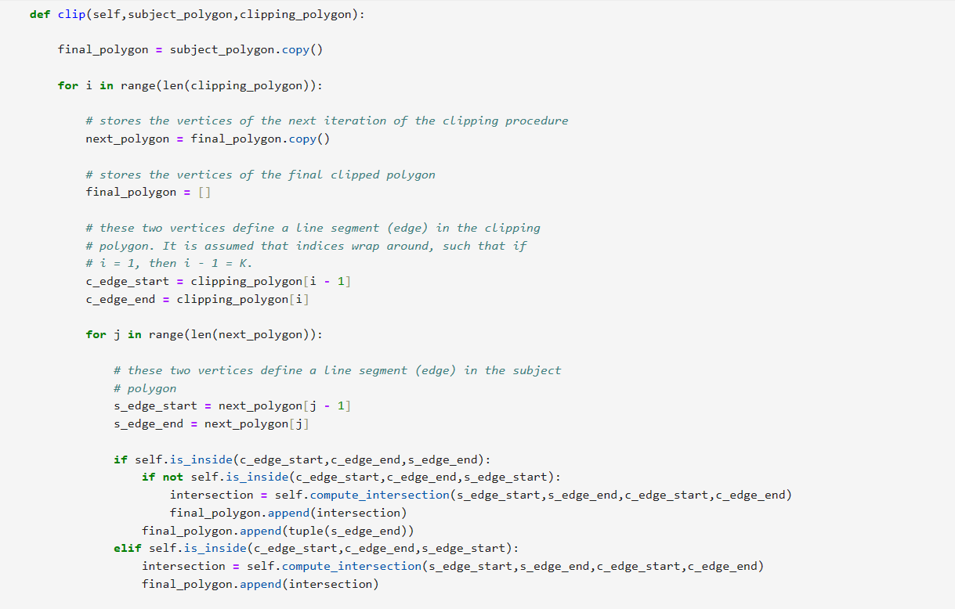

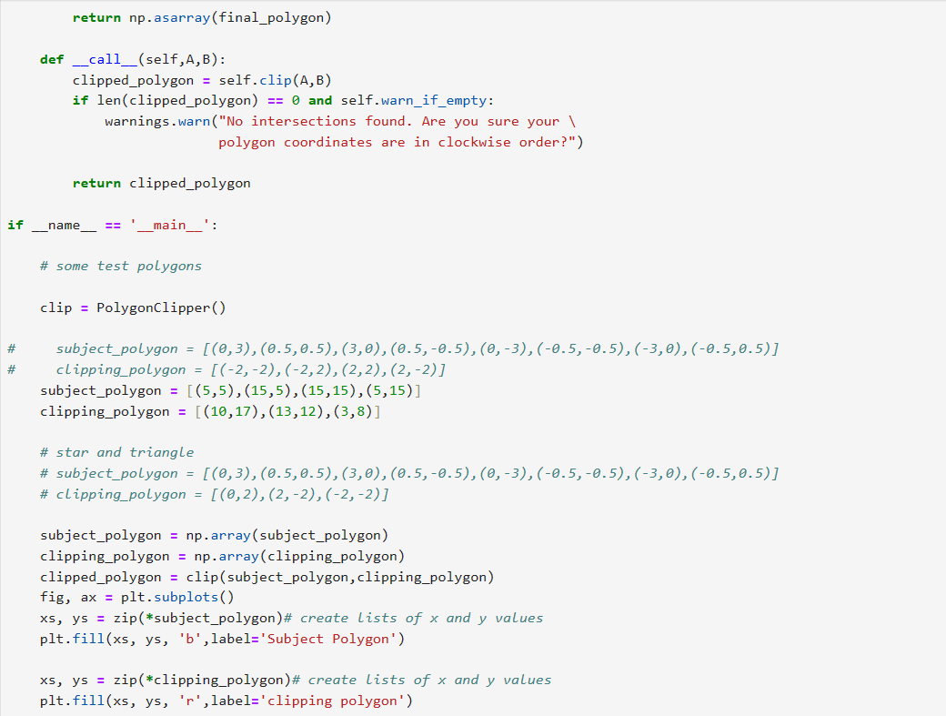

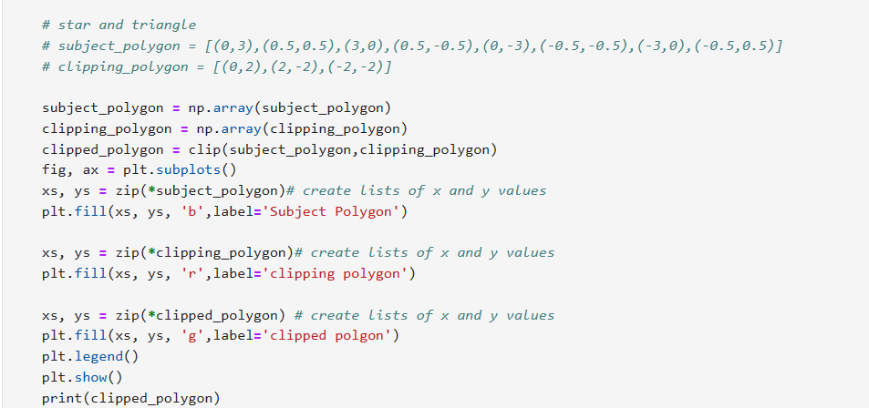

**OUTPUT**

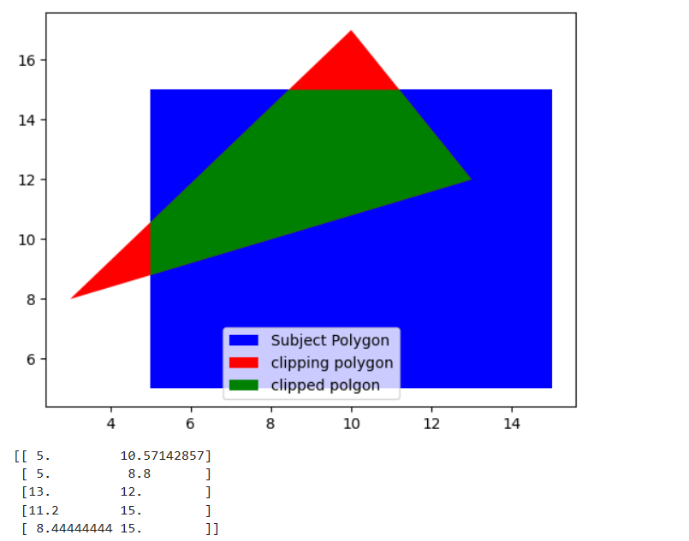

**PRACTICAL 05**

**5. Write a program to fill a polygon using Scan line fill algorithm.**

**CODE**

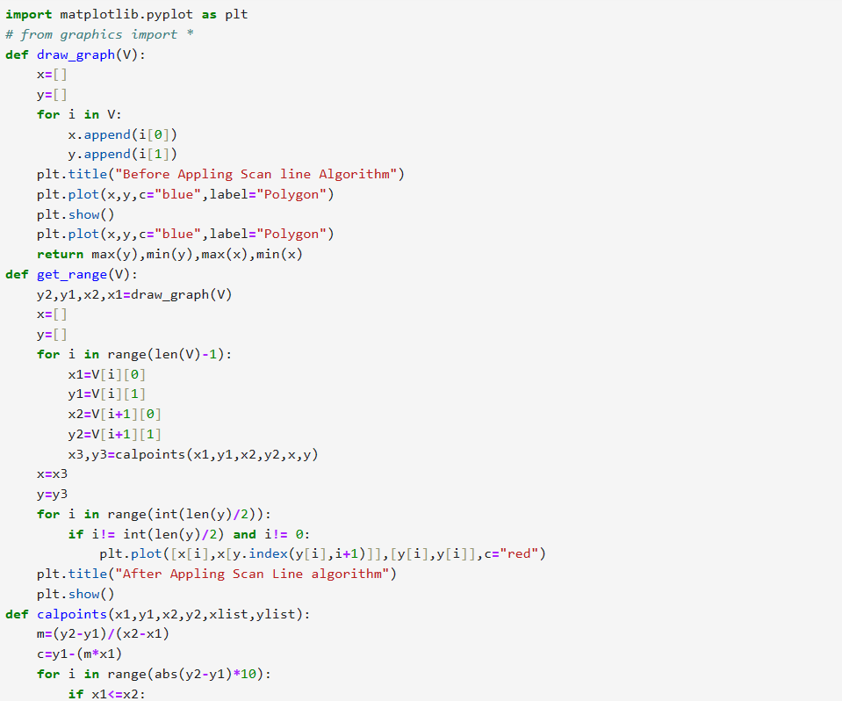

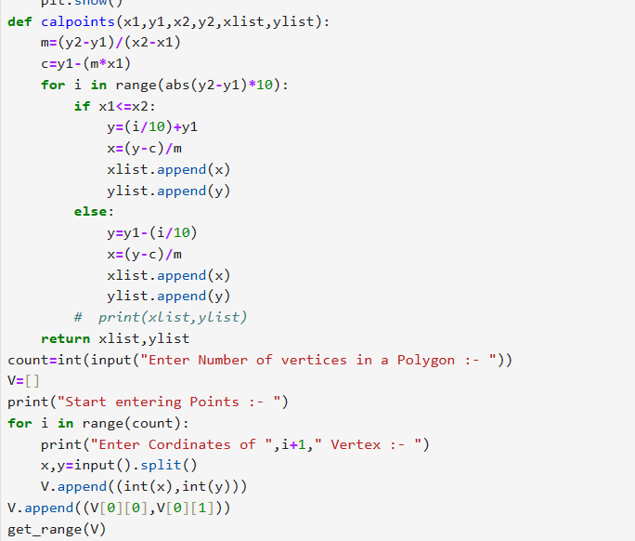

**OUTPUT**

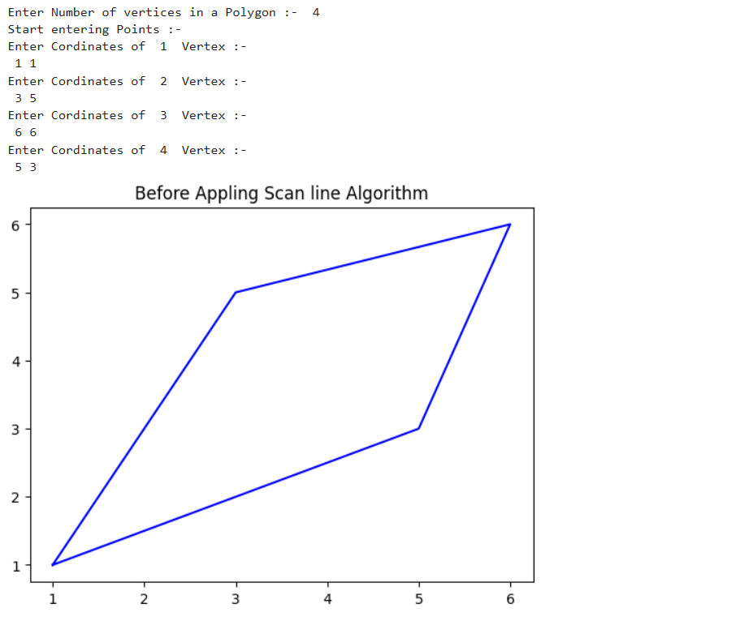

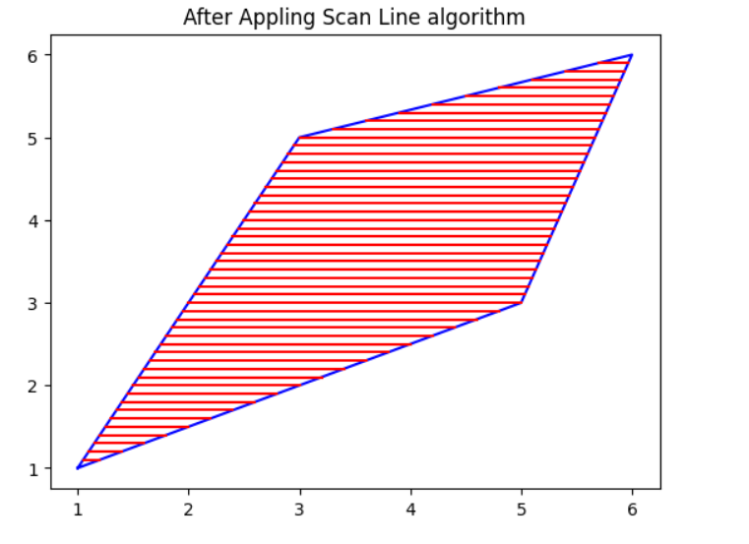

**PRACTICAL 06**

**6. Write a program to apply various 2D transformations on a 2D object (use homogenous Coordinates).**

**CODE**

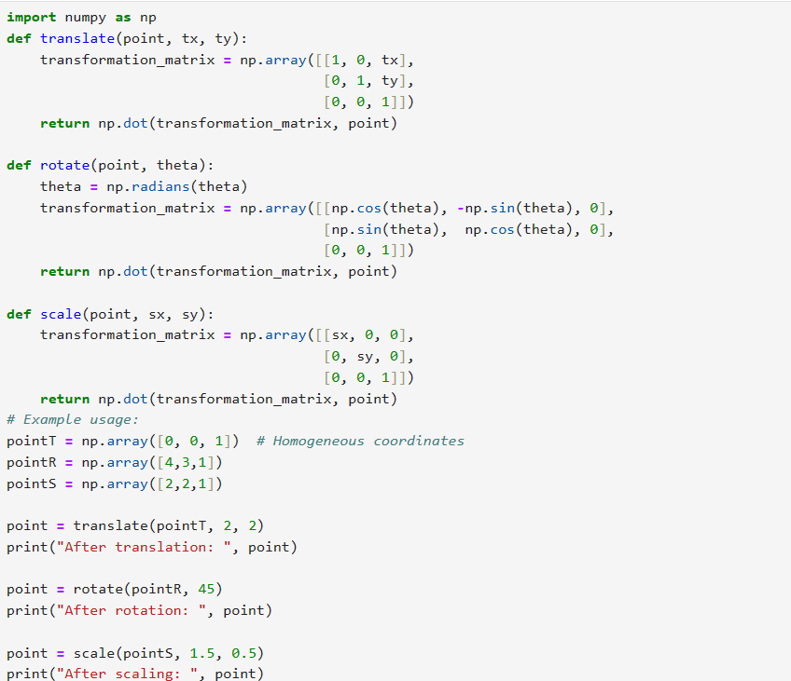

**OUTPUT**

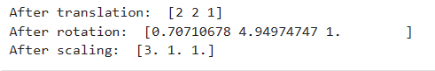

**PRACTICAL 07**

**7. Write a program to apply various 3D transformations on a 3D object and then apply parallel and perspective projection on it.**

**CODE**

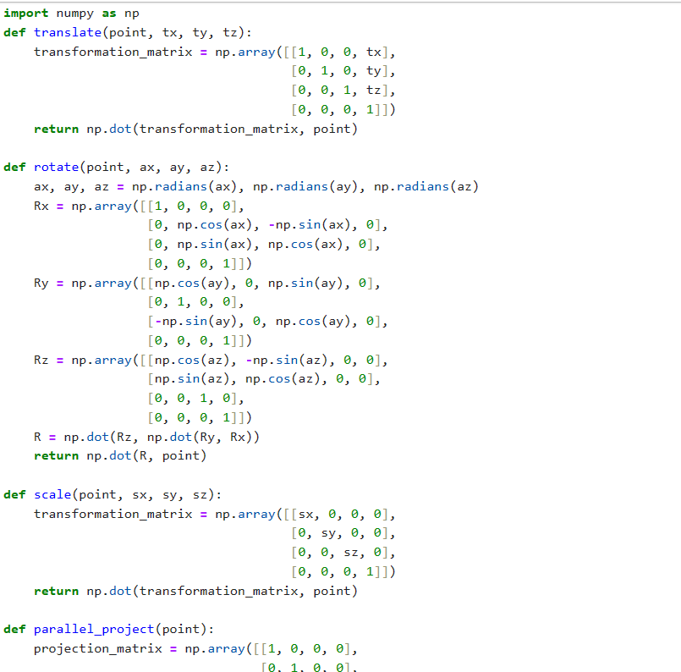

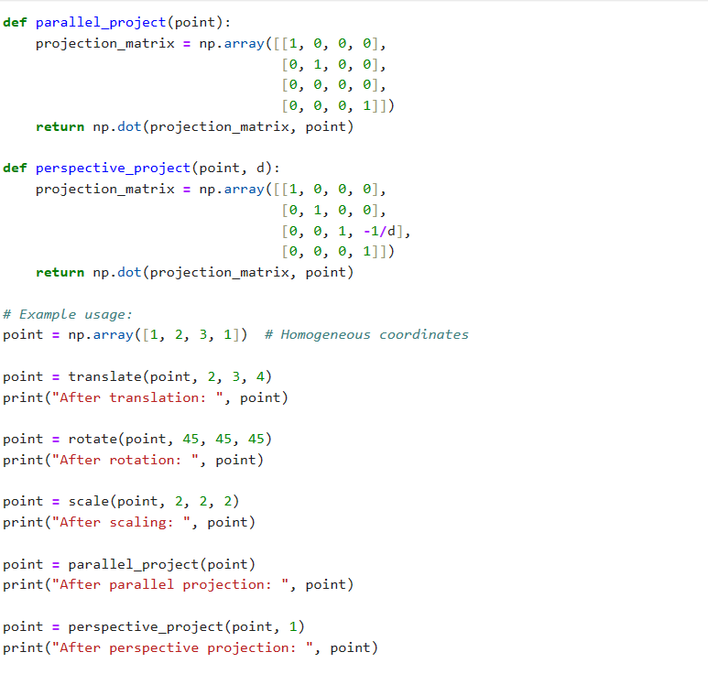

**OUTPUT**

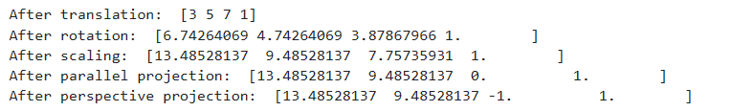

**PRACTICAL 08**

**8. Write a program to draw Hermite /Bezier curve.**

**CODE**

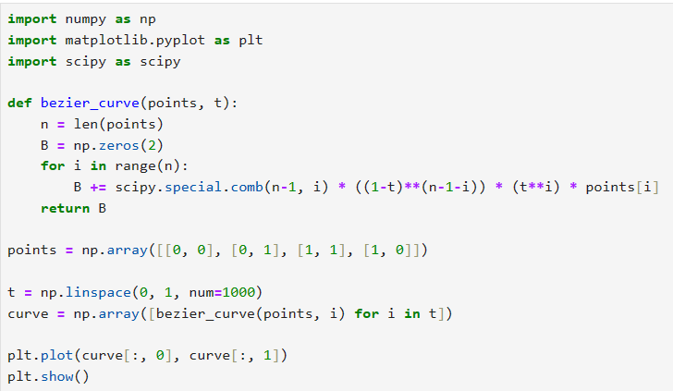

**OUTPUT**

